AI ASSISTED CODING:
Assignment 4.1:
NAME:VAISHNAVI VARDINENI
HT NO:2403A51431
BATCH:16
Task 1:
Write a Python function that validates an Indian mobile number. The function must ensure the number starts with 6, 7, 8, or 9 and contains exactly 10 digits. The function should return True if the number is valid and False otherwise.
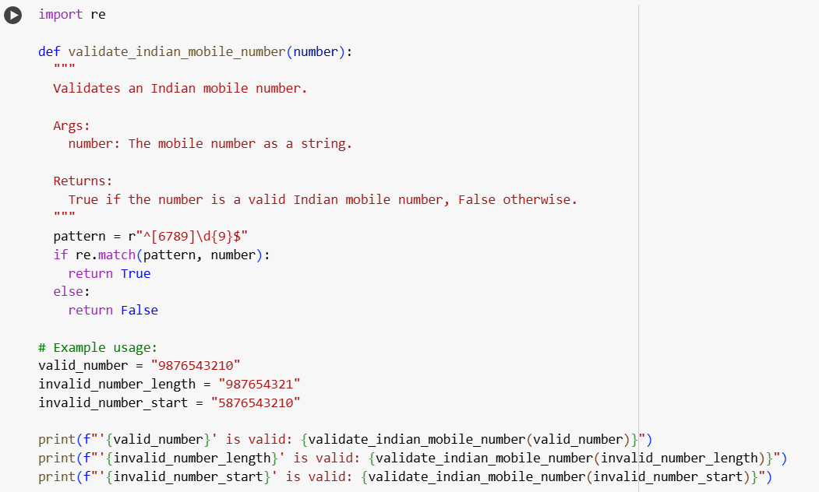

OUTPUT:
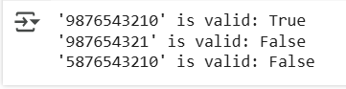

EXPLANATION:
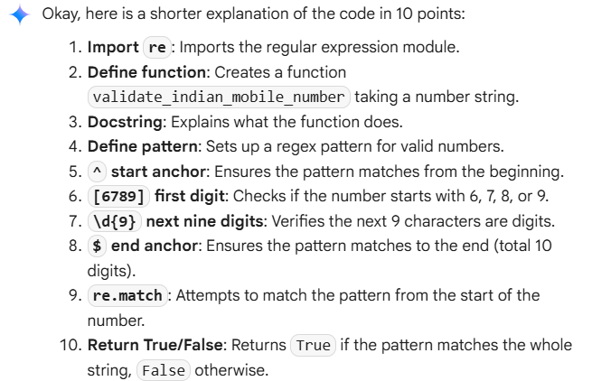

Task 2:
Write a Python function that calculates the factorial of a number. The function must handle 0! correctly (return 1) and return an appropriate message if the input is negative.
Example: Input = 5, Output = 120."
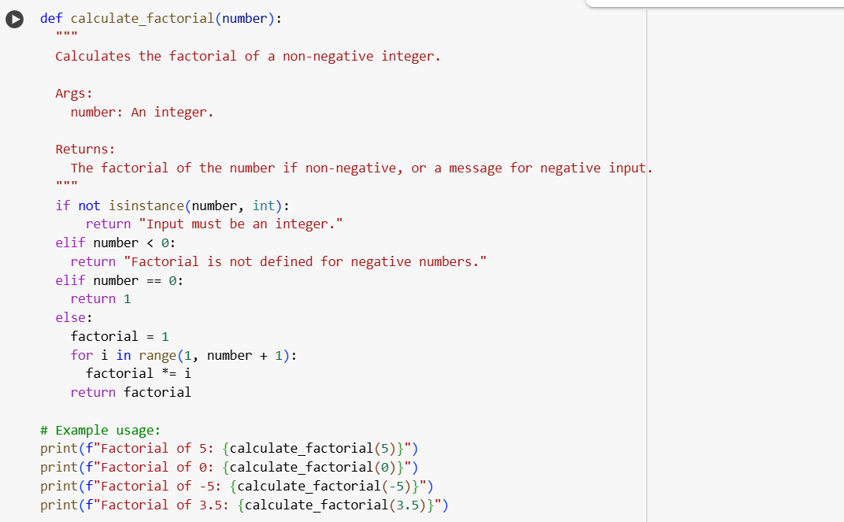

OUTPUT:
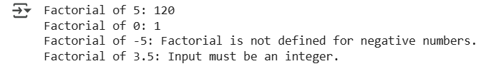

EXPLANATION:
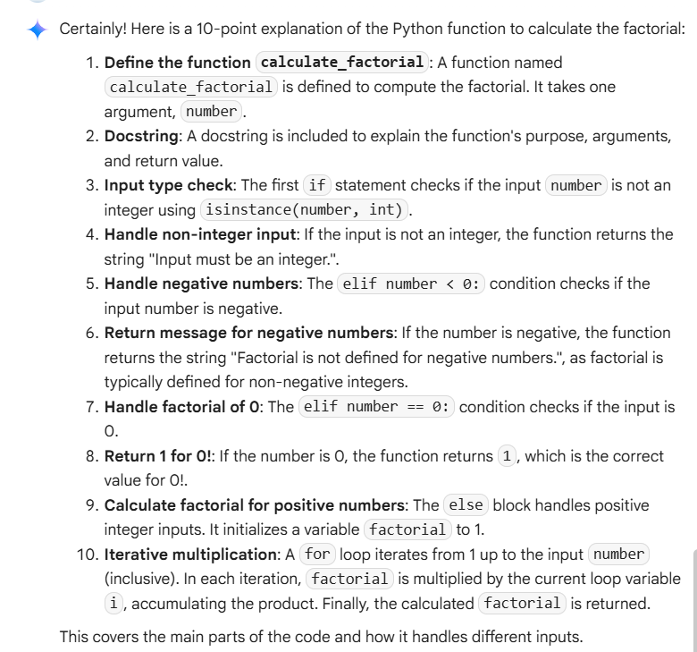

TASK 3:
Write a Python function that extracts student information from a nested dictionary. The function should return the student’s Full Name, Branch, and SGPA.
Example 1:
Input = {
"student": {
"name": {"first": "Amit", "last": "Sharma"},
"details": {"branch": "CSE", "sgpa": 8.7}
}
}
Output = {"Full Name": "Amit Sharma", "Branch": "CSE", "SGPA": 8.7}
Example 2:
Input = {
"student": {
"name": {"first": "Priya", "last": "Verma"},
"details": {"branch": "ECE", "sgpa": 9.1}
}
}
Output = {"Full Name": "Priya Verma", "Branch": "ECE", "SGPA": 9.1}
The function should work for any similar nested dictionary structure.
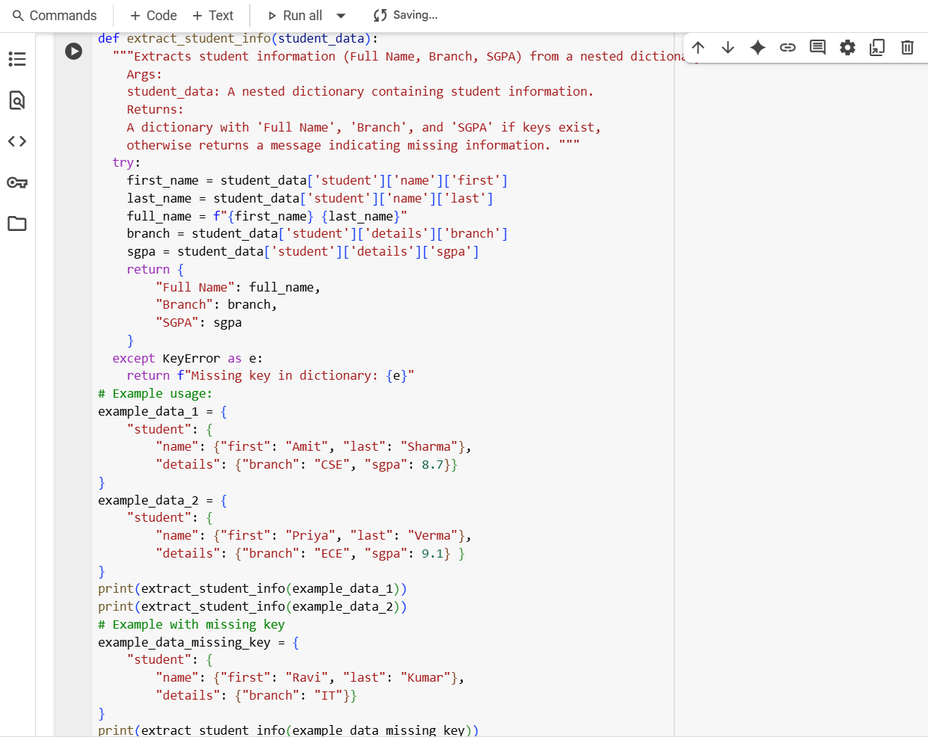
OUTPUT:
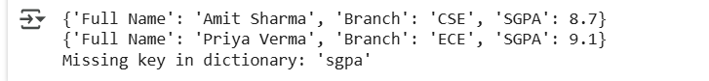
EXPLANATION:
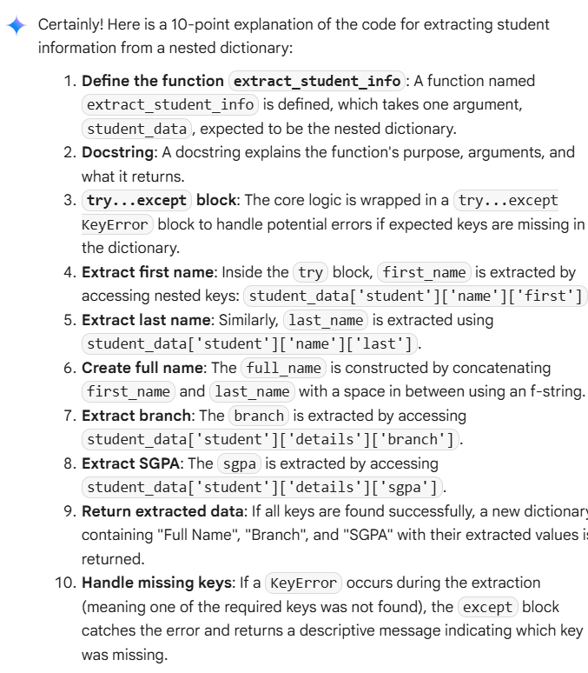
TASK 4:
Generate Python functions using three different prompting styles—zero-shot, one-shot, and few-shot—to perform CSV file analysis.
Each function should:
- Read a .csv file
- Return the total number of rows
- Count the number of empty rows
- Count the total number of words across the file
>> Zero-Shot Prompt
Write a Python function that reads a CSV file with 10 rows, 2 empty rows, and 100 words.
Output: {'Total Rows': 10, 'Empty Rows': 2, 'Word Count': 100}
Example 2:
Input: A CSV file with 3 rows, 0 empty rows, and 15 words.
Output: {'Total Rows': 3, 'Empty Rows': 0, 'Word Count': 15}
Now generate a Python function that works for similar CSV files and returns the correct analysis.

Code:
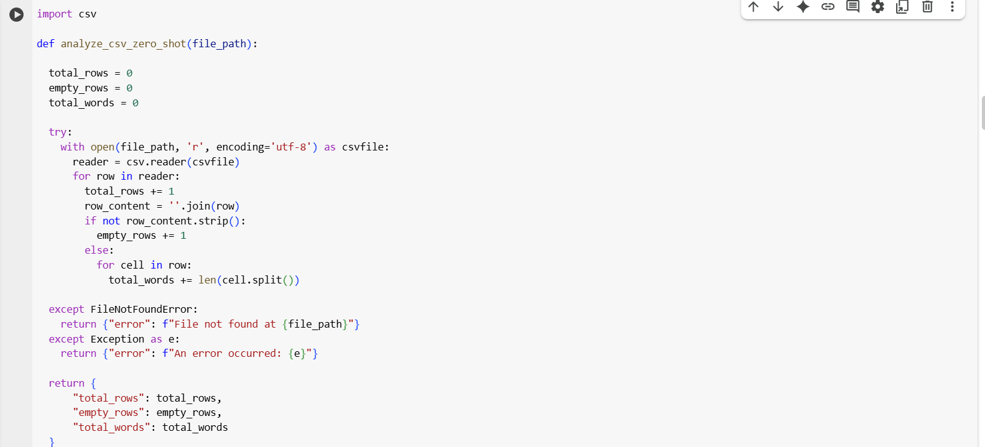
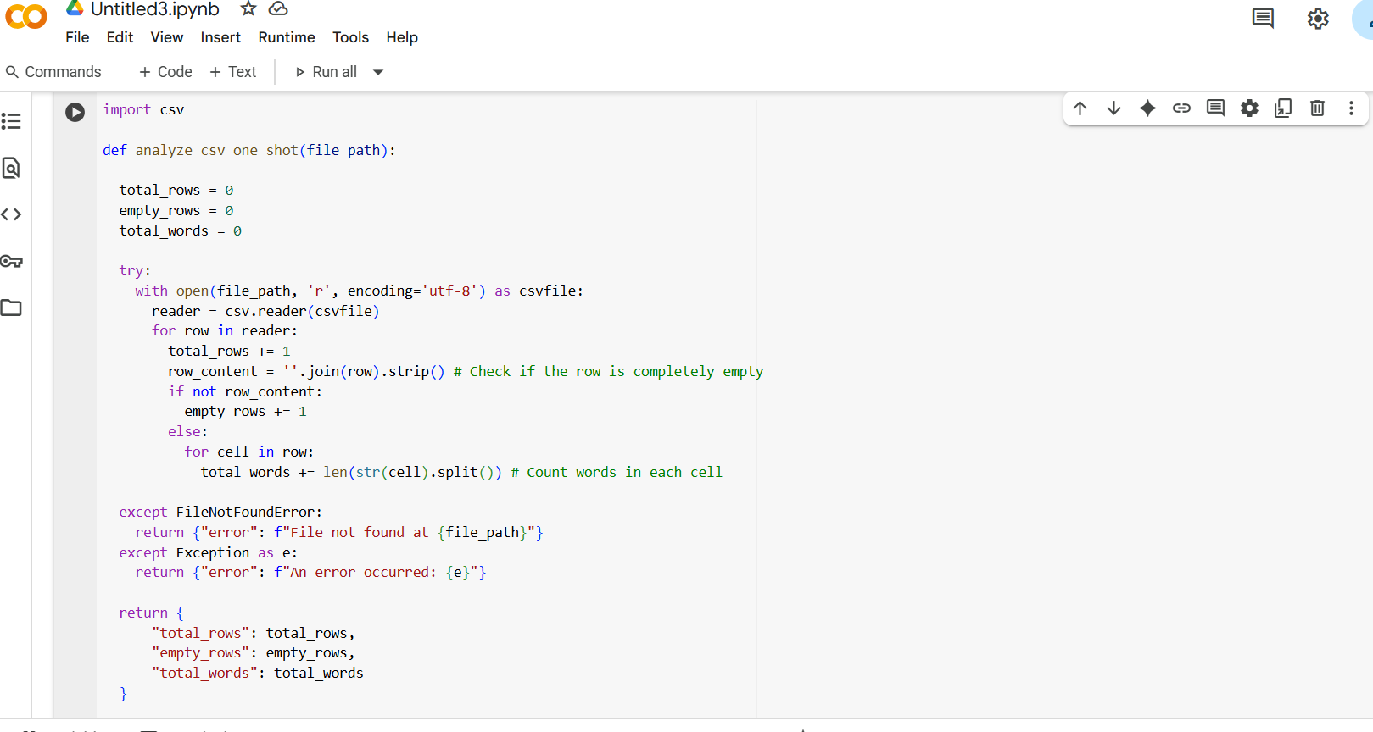
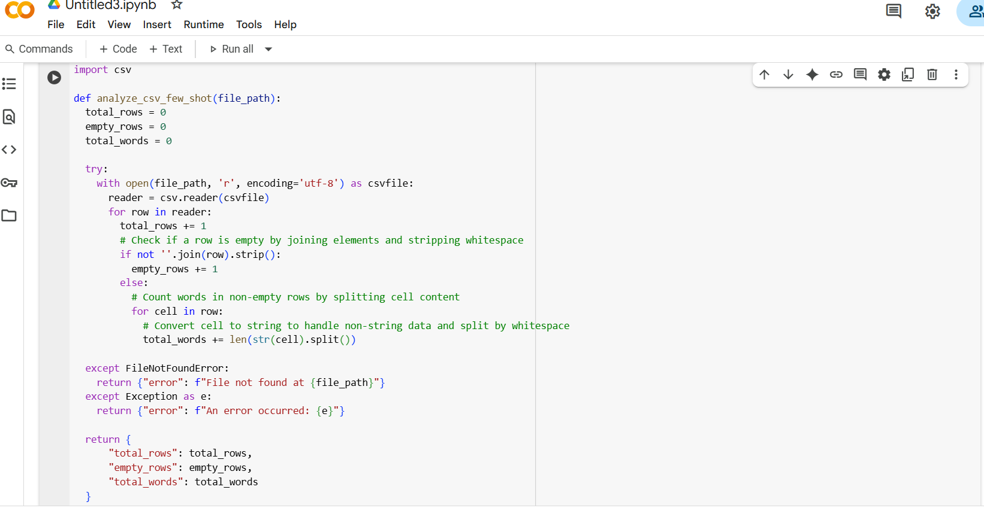
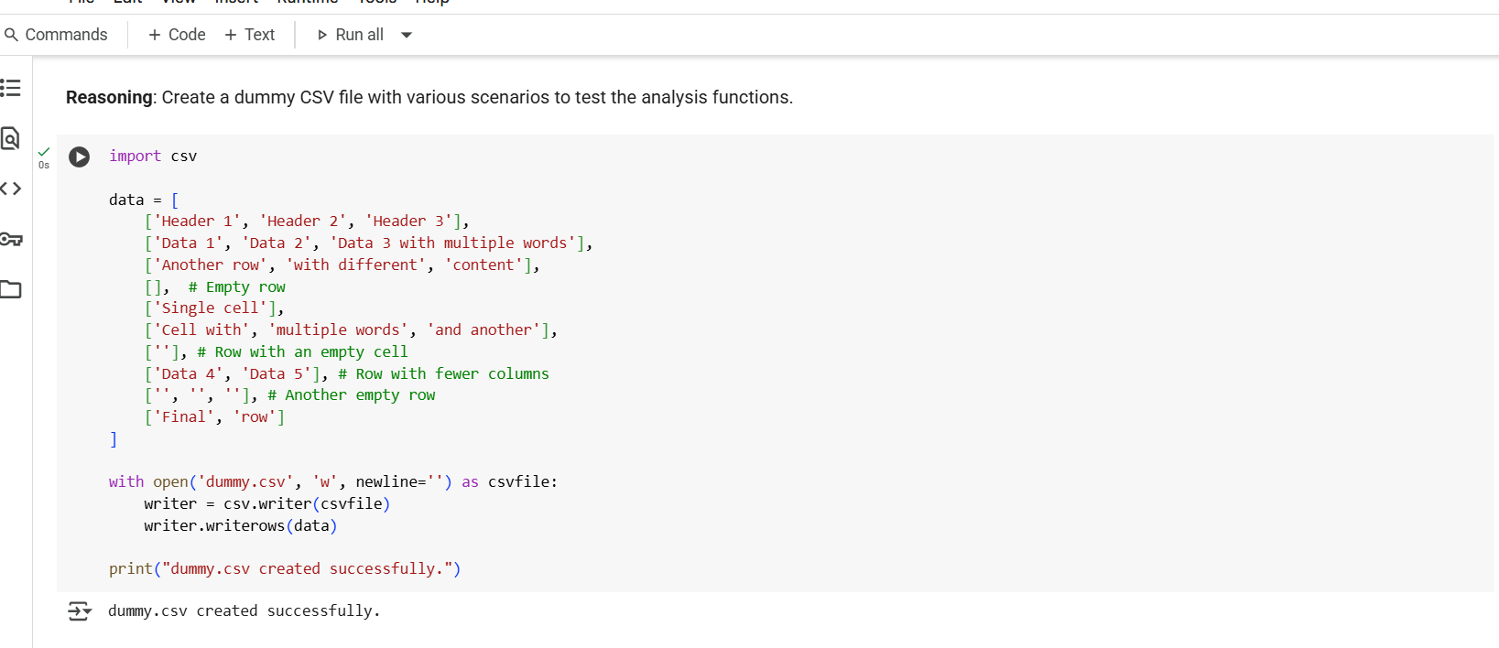
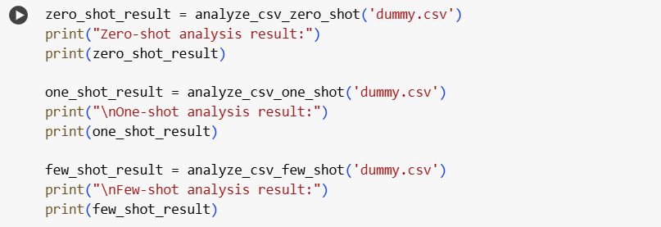
Output:
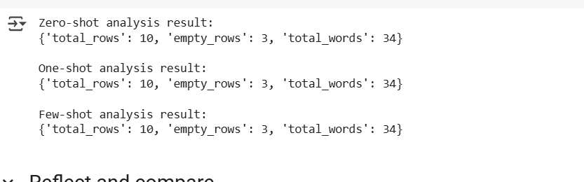
Explanation:
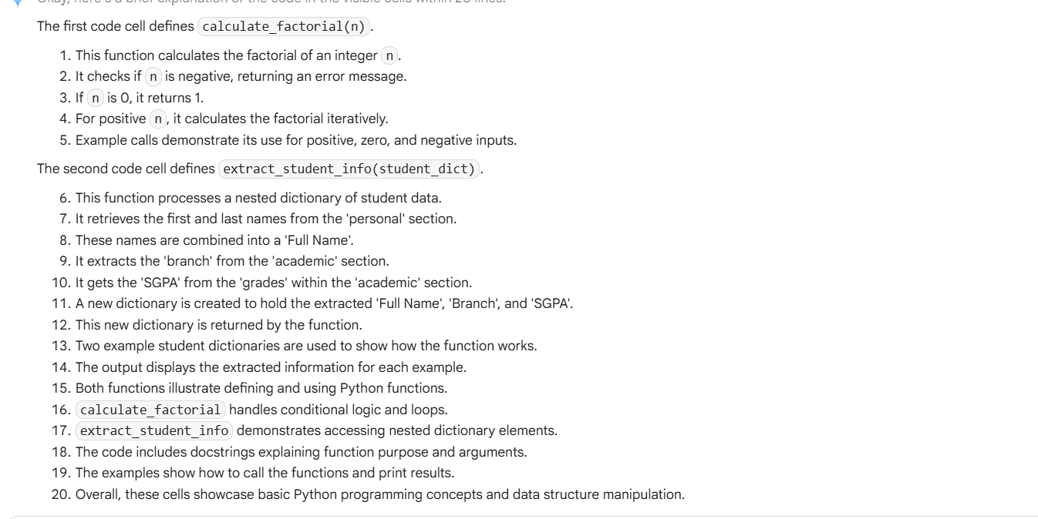
Task5:
Write a Python function called most_frequent_word(text) that accepts a paragraph as input and returns the most frequently used word. The function must:
- Convert all text to lowercase
- Remove punctuation
- Analyze word frequency
- Return the word that appears most often
Example 1
Input: "Data science is fun. Data is powerful. Science is evolving."
Output: "is"
Example 2
Input: "Python is great! Python is versatile. Python is popular."
Output: "python"
Example 3
Input: "AI tools are transforming industries. AI is the future. Tools help us adapt."
Output: "ai"
Now generate the function most_frequent_word(text) that works for these examples and similar ones.
Code:
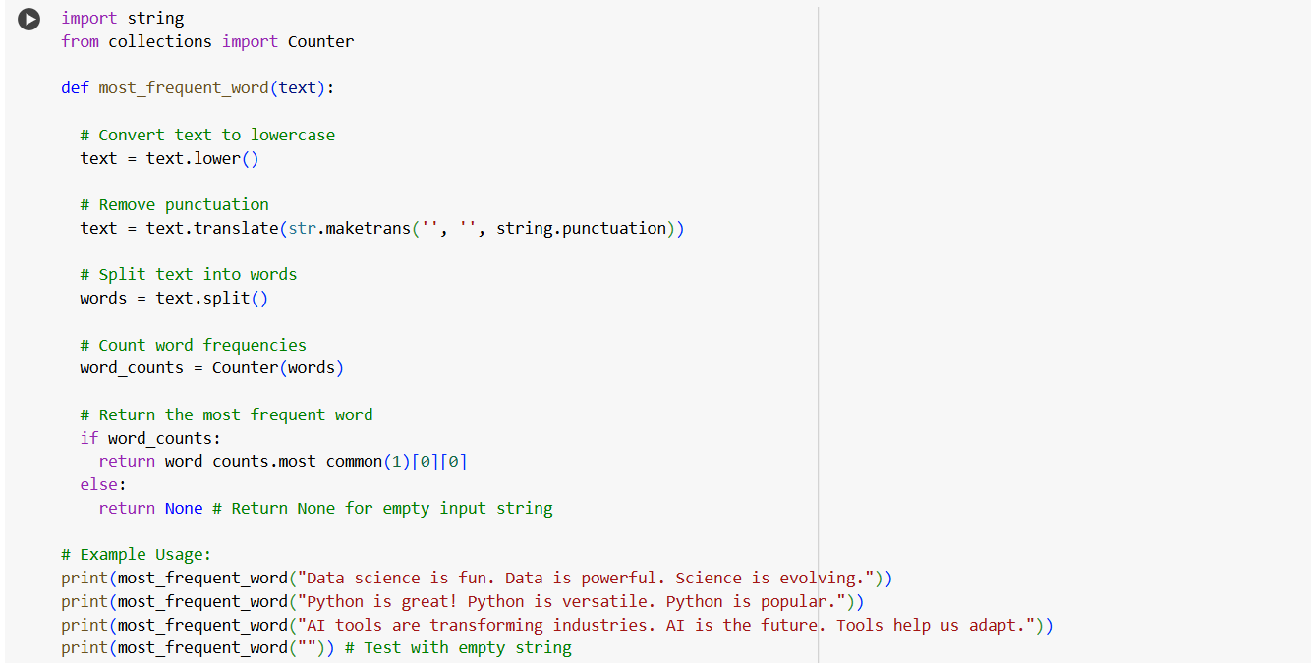
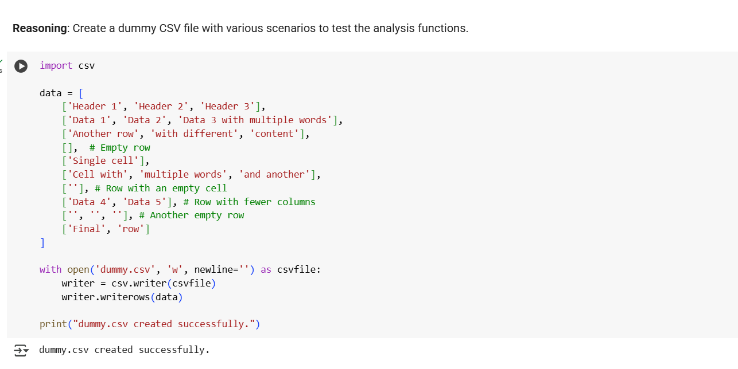

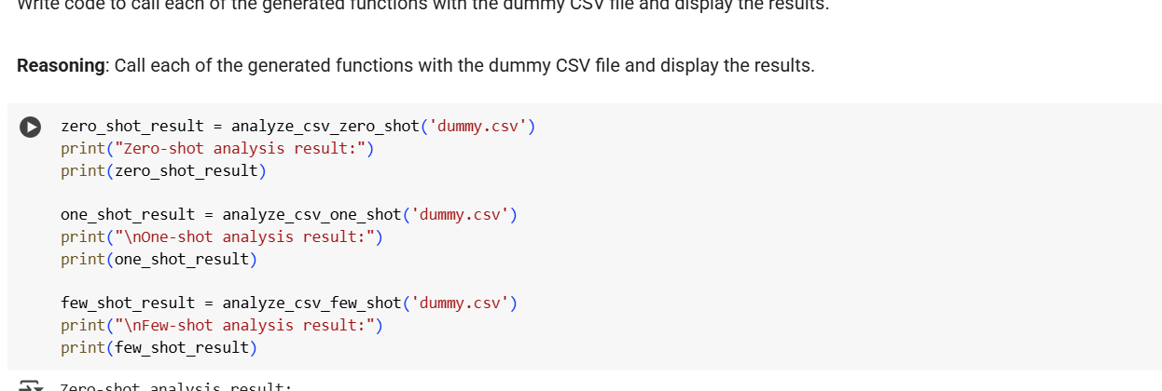

Output:
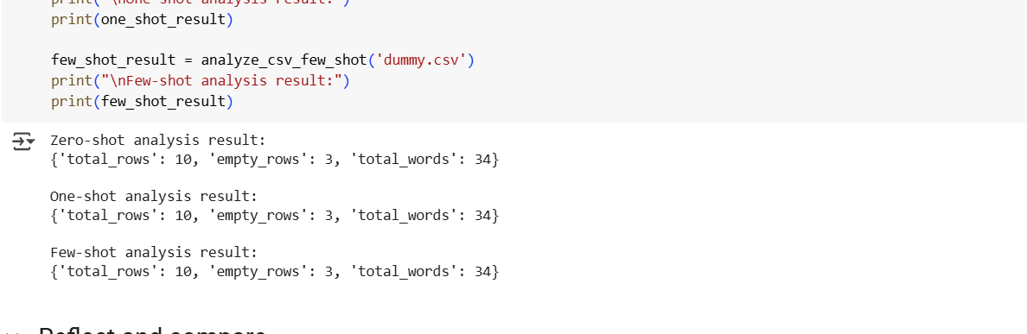

Explanation:
